## Western Australian Certificate of Education

**Semester 1 Examination, 2016**

##### Question/Answer Booklet

**COMPUTER**

**SCIENCE**

**Unit 1: Year 11 ATAR**

|  |  |  |  |  |  |  |  |  |  |  |
| --- | --- | --- | --- | --- | --- | --- | --- | --- | --- | --- |
| Student Number: In figures |  |  |  |  |  |  |  |  |  |  |

In words

**Time allowed for this paper**

Reading time before commencing work: ten minutes

Working time for paper: two hours 30 minutes

**Materials required/recommended for this paper**

***To be provided by the supervisor***

This Question/Answer Booklet

Multiple Choice answer sheet

###### *To be provided by the candidate*

Standard items: pens, pencils, eraser, correction fluid/tape, ruler, highlighters

Special items: non-programmable calculators, MATHOMAT and/or Mathaid and/or any system flowchart template

**Important note to candidates**

No other items may be taken into the examination room. It is **your** responsibility to ensure that you do not have any unauthorised notes or other items of a non-personal nature in the examination room. If you have any unauthorised material with you, hand it to the supervisor **before** reading any further.

**Structure of this paper**

|  |  |  |  |  |  |
| --- | --- | --- | --- | --- | --- |
| Section | Number of questions available | Number of questions to be answered | Suggested working time (minutes) | Marks available | Percentage of exam |
| Section Two:  Short answer | 20 | 20 | 75 | 55 | 40 |
| Section Three:  Extended answer | 3 | 3 | 75 | 77 | 60 |
|  |  |  |  | **Total** | 100 |

**Instructions to candidates**

1. The rules for the conduct of Western Australian external examinations are detailed in the *Year 12 Information Handbook 2016*. Sitting this examination implies that you agree to abide by these rules.

2. Write your answers in the spaces provided in this Question/Answer Booklet. A blue or black ballpoint or ink pen should be used. Wherever appropriate, fully labelled diagrams, tables and examples should be used to illustrate and support your answers.

3. You must be careful to confine your responses to the specific questions asked and to follow any instructions that are specific to a particular question. Where no specific instructions are given, you should feel free to use a range of formats to express your knowledge and understandings.

4. Spare pages are included at the end of this booklet. They can be used for planning your responses and/or as additional space if required to continue an answer.

* Planning: If you use the spare pages for planning, indicate this clearly at the top of the page.
  + Continuing an answer: If you need to use the space to continue an answer, indicate in the original answer space where the answer is continued, i.e. give the page number. Fill in the number of the question(s) that you are continuing to answer at the top of the page.

**Section One: Short answer** **40% (55 Marks)**

This section contains **20** questions. You must answer **all** questions. Write your answers in the spaces provided.

Spare pages are included at the end of this booklet. They can be used for planning your responses and/or as additional space if required to continue an answer.

* + Planning: If you use the spare pages for planning, indicate this clearly at the top of the page.
  + Continuing an answer: If you need to use the space to continue an answer, indicate in the original answer space where the answer is continued, i.e. give the page number. Fill in the number of the question(s) that you are continuing to answer at the top of the page.

Suggested working time: 75 minutes.

**Question 1 (2 marks)**

Explain, using an example, the difference between The System Development Life Cycle and Prototyping.

**Question 2 (3 marks)**

Your computer fails to recognise the USB you have plugged into a USB port. Identify three trouble shooting strategies you could use in this situation.

**Question 3 (3 marks)**

1. Identify the purpose of an ICT Code of Conduct. (1 mark)

1. Identify and justify the inclusion of two items into an ICT Code of Conduct written specifically for teachers within a secondary schooling environment. (2 marks)

Item 1:

Item 2:

**Question 4 (4 marks)**

Explain how the fetch-execute cycle interacts with a system’s RAM, system clock, control unit and registers.

**Question 5 (2 marks)**

Explain the difference between a solid state drive and a mechanical disk detailing why you would use one over the other.

**Question 6 (3 marks)**

Documentation including Context and Data Flow Diagrams are part of the Systems Development Life Cycle. Explain why this is so and in which stage(s) of the SDLC they are generally developed.

**Question 7 (1 mark)**

What is the difference between a Data Flow Diagram and a Context Diagram?

**Question 8 (3 marks)**

Describe the function of each of the following buses within a system unit:

Data Bus:

Address Bus:

Control Bus:

**Question 9 (2 marks)**

A user wants to detect and clean a virus-infected file as it is opened. Explain how would this be achieved?

**Question 10 (1 mark)**

Identify a technique used to minimise damage caused by electrostatic discharge.

**Question 11 (3 marks)**

Identify three data characteristics that a Data Dictionary will identify for a Database Management System.

Characteristic 1:

Characteristic 2:

Characteristic 3:

**Question 12 (3 marks)**

Identify three advantages of implementing a Relational Database Management System.

Advantage 1:

Advantage 2:

Advantage 3:

**Question 13 (4 marks)**

Identify and explain four troubleshooting strategies that could be used to ensure the hardware is run optimally.

**Question 14 (2 marks)**

Identify and explain two (2) tools a project manager could use to monitor and track the progress of a system development project.

**Question 15 (4 marks)**

Describe four data gathering techniques that can be used within the SDLC and at which stage they are likely to be used and why.

Technique 1:

Stage:

Why:

Technique 2:

Stage:

Why:

Technique 3:

Stage:

Why:

Technique 4:

Stage:

Why:

**Question 16 (4 marks)**

Identify four (4) errors with the following context diagram.

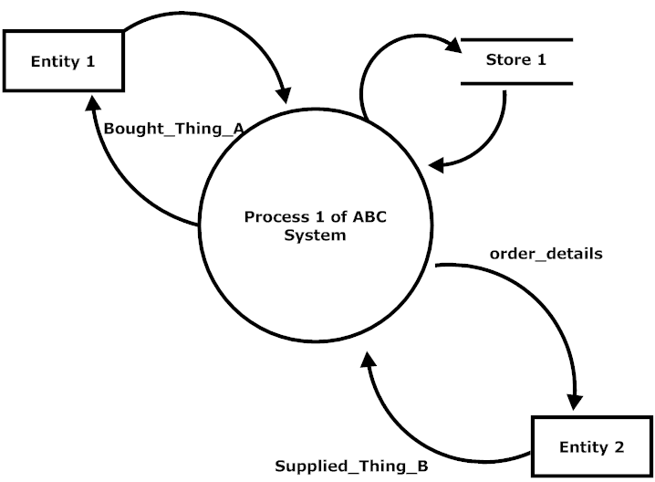

**Question 17 (3 marks)**

1. Explain the purpose of an Entity Relationship Diagram. (1 mark)

1. Where is it likely to be developed within the System Development Life Cycle? Justify your answer. (2 marks)

*Questions 18 – 20**relate to the following information*

Damian owns a small lunch bar in the City. Damian sells many food items but a supplier can only supply one food item. Each supplier has a supplier number and Damian needs their address and phone number stored in the database. Each food item also has an item number and a menu item description (eg, hot, cold, drinks, confectionary etc).

**Question 18 (6 marks)**

Draw the ERD to reflect the current business rules for Damian’s business indicating primary keys, foreign keys and relevant attributes.

**Question 19 (1 mark)**

The business rules have changed. Damian can now buy many food items from a supplier. Describe how this will change the ERD that you have drawn in Question 18.

**Question 20 (1 mark)**

Damian has been told he needs a ‘Date Purchased’ attribute and he has been advised to use a mask. Why would he have been advised to do this and how will this impact the data?

**End of Section One**

**Section Two: Extended answer 60% (77 Marks)**

This section contains **three (3)** questions. You must answer **all** questions. Write your answers in the spaces provided.

Spare pages are included at the end of this booklet. They can be used for planning your responses and/or as additional space if required to continue an answer.

* + Planning: If you use the spare pages for planning, indicate this clearly at the top of the page.
  + Continuing an answer: If you need to use the space to continue an answer, indicate in the original answer space where the answer is continued, i.e. give the page number. Fill in the number of the question(s) that you are continuing to answer at the top of the page.

Suggested working time: 75 minutes.

Refer to source sheet

Question 21 refers to Figure A: Page 1 of the Source Sheet.

**Question 21 (15 marks)**

1. There are only four (4) types of employment status. What tool could you use in column E2 onwards to make data input more efficient? (1 mark)

1. ABC Pty Ltd wish to apply a pay raise of 2.91% to everyone’s salary. What formula would you use to do this? (include all absolute and relative cell references). (3 marks)

1. What action would you take to ensure this is applied to all employees listed in this spreadsheet efficiently? (1 mark)

1. ABC Pty Ltd wish to calculate the average salary paid to its Full-Time employees. What combination of functions could be used to do this? (3 marks)

1. Employees tax is calculated according to the scale in range N2:P8. At $25,000 a person would have paid $6,300 in tax. This calculated as follows

($25,000 - $5000) x 21% = $6,300

A person earning $26,000 would have paid

$6,300 + ((26000-25000)x 25%) = $6,550

1. What sort of formula would be suitable to calculate tax in column K? (1 mark)

1. Write the formula to be used in column K. (6 marks)

**Question 22 (21 marks)**

This question refers to Source B on page 1 of the Source sheet.

1. ABC Pty Ltd have been advised to create a relational database to store employee data instead of the current spreadsheet. Fixem have advised that this new relational database can also be accessed over the internet.
2. What are two benefits of using a relational database over a spreadsheet?

(2 marks)

1. Explain disadvantage of creating a relational database instead of continuing to use the spreadsheet? (2 marks)

1. Identify two ethical issues potentially associated with establishing a relational database system that can also be accessed online. (2 marks)

1. Identify an issue with the following Entity Relationship Diagram according to the business rules contained in Source B. (2 marks)

**Employee**

**M**

**Location**

**Department**

**has**

**1**

**M**

**contains/**

**is contained**

**M**

1. Redraw the Entity Relationship Diagram below resolving the issue identified in (b) and listing only primary and foreign keys for each entity. (13 marks)

**Question 23 (41 marks)**

This question refers to Source C, page 2 of the Source Booklet.

1. Fixem have advised that they will undertake a System Development Life Cycle (SDLC) approach rather than a prototype approach. Explain why the SDLC approach may be suitable in this situation. (3 marks)

1. Identify two types of systems development documentation and state in which part of the Systems Development Life Cycle they will developed. (4 marks)

1. Complete the context diagram for the new ABC Human Resource Management System below. You may create more entity shapes as required. (14 marks)

**Advertise**r

1. Create a level 0 DFD using the following outline below (20 marks)

**End of Examination Questions**

Additional working space

Question Number:___________

Additional working space

Question Number:___________

Additional working space

Question Number:___________